Community Assessment Report
Gallatin County, MT

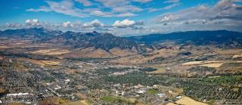

- Prepared by: Gallatin County, MT CTC Data Working Group
- May 27, 2020
- Sponsored by: Butte Cares

Community Assessment Report Contents

I. Introduction Letter

II. Executive Summary
A. The Gallatin County, MT Communities That Care Mission Statement

III. Introduction
A. The Gallatin County, MT Communities That Care effort
- About the Communities That Care system
- Key accomplishments in Gallatin County, MT
B. The risk- and protective-factor assessment
- Goals
- How the assessment will be used
- Data collection methods
- Prioritization methods

IV. The Community Assessment Data
- Risk factors
- Community Domain
2. Peer and Individual Domain
B. Protective factors
- Community Domain
C. High risk behaviors

V. Conclusion
- Community strengths
- Community priorities
- Next steps

VI. Acknowledgments

VII. References

Introduction Letter
It is with great pleasure that our organizations proudly come together to share the 2020 Community Assessment Report, Communities That Care, for Gallatin County, MT. For the past year, members from our organizations have been collaborating, organizing, and working to determine the most effective ways to improve the health and well-being of our youth using the Communities That Care framework.

With a focus on prevention, this report aims to identify strategies to decrease high risk behaviors amongst our youth that result in poor health outcomes. We strive to address community issues such as underage drinking, tobacco use, access to firearms, and more to encourage our youth to excel and thrive in Gallatin County, MT.

We are excited to share our Community Assessment Report as a community guide to create a healthy, equitable, and inclusive community where youth are empowered to thrive, feel a sense of belonging, and make meaningful contributions to the world around them.

Sincerely,

Danika Comey, MPH
Bozeman Health

Heather Demorest, CHES
Gallatin City-County Health Department

Amanda Knick, MPH
Bozeman Help Center, 211

Edward Szczypinski
Communities That Care Gallatin County, MT Coordinator

Karl Vanderwood, PhD
Gallatin City-County Health Department

Executive Summary

This report analyzes the results of the Risk and Protective Factor Assessment and data collection completed as part of Gallatin County’s Communities That Care effort. The Communities That Care system is a way for members of a community to work together to prevent youth high risk behaviors, including substance use, delinquency, teen pregnancy, dropping out of school, and violence. This system was developed by Dr. David Hawkins and Dr. Richard Catalano. It is based on their research, which has identified risk factors that predict youth high risk behaviors and protective factors that buffer children from risk and help them succeed in life.

A key goal of the Communities That Care effort is to identify which risk factors, protective factors and high risk behaviors are prevalent in our community, and to implement evidence-based programs that address the unique Gallatin County community’s profile. To that end, the Risk and Protective Factor Assessment work group, also called the Data Group, collected and analyzed different data from a variety of sources within Gallatin County, Montana. Then, with input from community partners, this group identified priority risk factors to address, and community strengths.

The assessment was completed using the 2018 Montana Prevention Needs Assessment Survey and other publically available data sources such as the 2017 Community Health Needs Assessment, the 2018 Youth Behavior Risk Survey, and other public data sources.

Based on the analysis of the data and input from community partners, the following risk factors were identified as priorities for community attention and action:

- Community laws and norms favorable towards drug use, firearms, and crime (Community Domain)
- Favorable attitudes toward the high risk behavior (Peer and Individual Domain)

These risk factors were selected as priorities for prevention action primarily because data indicated that the high risk behaviors associated with these risk factors are significantly elevated in Gallatin County.

The review of the data sources also revealed Gallatin County’s strengths. The Data Group determined that opportunities for prosocial involvement is a protective factor that can decrease the negative health outcomes associated with substance use amongst youth. This is an important area of strength on which to build to help promote well-being and protect youth from the health outcomes associated with high risk behaviors.

This report recommends that the community pay particular attention to the risk factors noted above when developing the community’s action plan to prevent high risk behaviors among youth and promote community well-being in Gallatin County, MT.

Gallatin County, MT Communities That Care Mission Statement

Gallatin County envisions a healthy, equitable, and inclusive community where youth are empowered to thrive, feel a sense of belonging, and make meaningful contributions to the world around them

Introduction

The Gallatin County, MT Communities That Care Effort
In the fall of 2019, Gallatin County, Montana began implementing the Communities That Care prevention planning system. Developed by Dr. David Hawkins and Dr. Richard Catalano of the Social Development Research Group in Seattle, Washington, the Communities That Care system is a way for members of a community to work together to efficiently and effectively promote positive youth development and prevent high risk youth behaviors such as substance use, delinquency, teen pregnancy, school dropout, and violence.

Gallatin County implemented the Communities That Care process to achieve the community’s vision that Gallatin County will be a healthy, equitable, and inclusive community where youth are empowered to thrive, feel a sense of belonging, and make meaningful contributions to the world around them.

Key accomplishments to date:
- In October of 2019, community leaders attended a Key Leader Orientation and committed to the Communities That Care effort.
- In January of 2020, a Community Board was formed. Members attended a Community Board Orientation and established a structure for the Gallatin County Communities That Care effort. This included forming work groups to achieve the various steps in implementing the Communities That Care process.
- In February 2020, the Risk and Protective Factor Assessment work group attended the Community Assessment Workshop and developed a plan for completing the community risk and protective factor assessment. This report is the result of that assessment.

The Community Assessment
Dr. Hawkins and Dr. Catalano have identified risk factors that predict high risk behaviors in youth, and protective factors that help protect young people from those risks. By addressing risk and protective factors, communities can help prevent adolescent high risk behaviors and promote positive youth development. A key goal of the Communities That Care system is for communities to develop a profile of the risk factors, protective factors, and high risk behaviors in their community, and to develop a plan for addressing the risk factors that are most elevated while enhancing protective factors.

This report represents the first step in that process. The Risk and Protective Factor Assessment work group has collected data on risk factors, protective factors and high risk youth behaviors in Gallatin County. With input from community partners, the work group has identified Gallatin County’s community strengths and the priority risk factors to address in the prevention plan.

Data collection methods
The 2018 Montana Prevention Needs Assessment Survey was administered in spring 2018 in grades eight, ten, and twelve. Schools were also offered the option of administering the survey to students in grades seven, nine, and eleven. The 2018 results compiled surveys from 14,445 from more than 150 unique schools. The complete results are provided in the 2018 Montana Prevention Needs Assessment Survey report. Connecting this data to the Communities That Care framework, Dr. Hawkins and Dr. Catalano have identified public data indicators that have been shown to be valid and reliable measures of certain risk factors and high risk behaviors that are not measured by the survey, including extreme economic deprivation, availability of drugs and alcohol, teen pregnancy, and school dropout. The Risk and Protective Factor Assessment work group reviewed data from local and state agencies to supplement the 2018 Montana Prevention Needs Assessment Survey.

Other data sources
The Data Group collected public data from a variety of sources to help supplement the conclusions reached in the 2018 Montana Prevention Needs Assessment Survey. Data sources reviewed are:
- Gallatin County unemployment data from 2019
- 2019 Temporary Assistance for Needy Families (TANF) enrollment
- 2019 Supplemental Nutrition Assistance Program (SNAP) participant numbers
- Analysis of tobacco and marijuana retailer data
- 2019 Montana Youth Behavior Risk Survey
- Growth and Enhancement of Montana Students, School Dropout Rates
- Growth and Enhancement of Montana Students, Free and Reduced National School Lunch Program
- Data from the State of Montana Suicide Prevention Coordinator
- Montana Board of Crime Control
- 2017 Community Health Needs Assessment Report: Gallatin, Madison, and Park Counties Montana
- Montana State University Dean of Students 2018-2019 Annual Report
- The Human Resource Development Council Community Needs Assessment 2017.

How the priorities were identified
The Risk and Protective Factor Assessment work group analyzed the data to identify which risk factors are most elevated in Gallatin County. This initial short list of priorities will be presented to the Community Board, which will discuss other considerations, such as the community’s ability to have an impact on certain risk factors at this time. By consensus, the Community Board will then select the final priorities for prevention action in Gallatin County. Those priorities will be presented to Key Leaders for endorsement.

Figure 1: Gallatin County Risk Factors, from the 2018 Montana Prevention Needs Assessment Survey
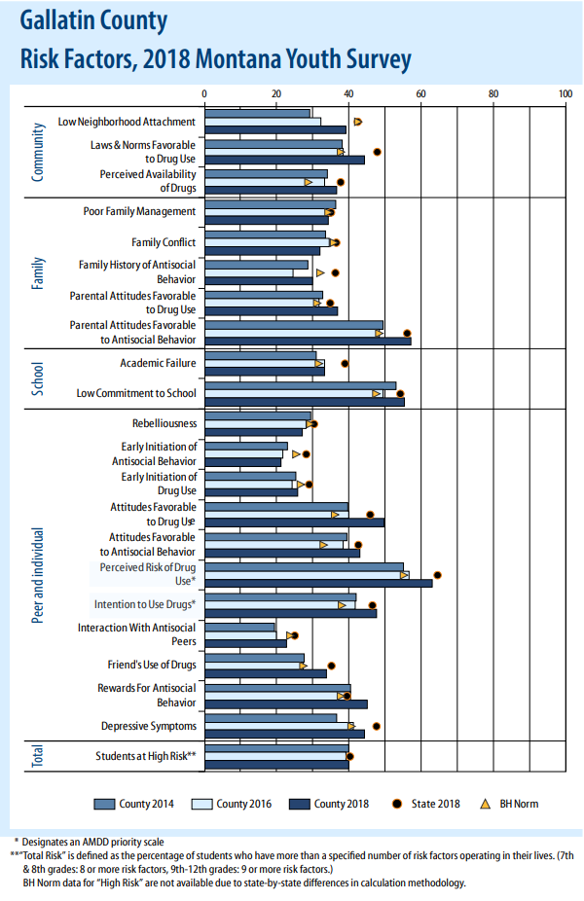

Report Overview
The next sections of the report provide detailed information and analysis of the risk factors, protective factors and high risk behaviors in Gallatin County. The conclusion presents the final list of priorities and recommendations for future action.

Risk Factor:
Community Laws and Norms Favorable Towards Drug Use, Firearms, and Violence

After extensive review of the data, the Data Group selected “Community Laws and Norms Favorable Toward Drug Use, Firearms, and Violence” as the main community level risk factor to target due to the high rates of substance use and abuse in Gallatin County, favorable community norms and attitudes towards substance use, and high density of firearms in homes in Gallatin County. Drug use includes alcohol, tobacco, marijuana, and illicit drugs.

According to the Communities That Care framework, there are a series of measureable behaviors directly linked back to each risk factor. The “Community Laws and Norms Favorable Toward Drug Use, Firearms, and Violence” risk factor is linked to substance use, delinquency, and violence. Although all contributing risk factors will be examined, the main focus that the data group would like to draw attention to is the high rates of alcohol use, the community acceptance of alcohol use, and favorable community attitudes towards tobacco, marijuana, and firearms in Gallatin County.

“Each risk and protective factor can be linked to specific types of interventions that have been shows to be effective in either reducing risk(s) or enhancing protection(s)” (2018 Montana Prevention Needs Assessment Survey, p.9)

The 2017 Community Health Needs Assessment found that one in every four adults in Gallatin County is an excessive drinker. This statistic remains unchanged since 2011. As a result, substance use and tobacco use were identified as one of the top community health needs in 2017. This is especially important to note because adults are role models for children in the community. Furthermore, community norms are shaped by community behaviors. Excessive alcohol use among adults models to youth that using substances, and using substances to excess, is appropriate social and community behavior and is “normal.” This is reflected in the 2018 Montana Prevention Needs Assessment summary where students indicated their intention to use substances once they are adults.

One main indictor of alcohol use is alcohol distributor density data. In Gallatin County, there are 269 alcohol retailers compared to the state median of 28.5 retailers. In terms of population level data, Gallatin County has 2.45 alcohol retailers per 1,000 people compared to the state average of 3.06 alcohol retailers per 1,000 people. This includes on-premise and off-premise alcohol sales locations. The sheer density and availably of alcohol in Gallatin County indicates to youth that use of alcohol is the norm and is socially acceptable in this community. Students intend to use alcohol when they are adults because this is normal in Gallatin County.

In terms of tobacco density in Gallatin County, there are 127 tobacco retailers and 75 marijuana retailers for a density of 0.8 tobacco retailers per 1,000 people. This is slightly lower than the Montana state average of 1.0 tobacco retailers per 1,000 people. This includes the sale of tobacco only (no vapor products), vapor products only, marijuana, and tobacco and vapor products. Additionally, there are 25 tobacco retailers in Gallatin County that are within 500 feet to 0.5 miles away from a school.¹ The implication is that high density of tobacco retailers and close proximity to school conveys to student that there is little harm associated with the use of these products because they are so widespread. High retailer density and high availability of tobacco and vapor products, particularly in gas stations, leads to a reduced perception of harm. With such high density of tobacco retailers, the Gallatin County community has favorable laws and norms toward tobacco use.

Crime data for alcohol and tobacco related crimes have fluctuated over the past five years among youth. In 2019, there was a total of 210 alcohol and tobacco related crimes for those aged 0-17 in Gallatin County. The two leading offenses for this category are “purchase/possess intoxicant” and “tobacco possession.” A large percentage of crime data is related to alcohol and tobacco.

Drug related crime has declined in the past five years in Gallatin County. Illicit drug use remains lower in Montana than national averages. In 2019, there were 145 total crimes (not including alcohol and tobacco related crimes) for those aged 0-17 in Gallatin County. The two leading offenses for this category are “possession of dangerous drugs” and “possession of drug paraphernalia.” However, “possession of drug paraphernalia” has significantly decreased in the past five years and national norms towards marijuana use have become more favorable.

“47.9% of students in Montana are at an increased risk of engaging in problem behaviors due to the increased risk associated with lax community attitudes towards substance use” (2018 Montana Prevention Needs Assessment Survey, pg12)

When examining the use of substances in Gallatin County, it is crucial to review usage from college students at Montana State University. Within the Montana State University student population, 78% of conduct cases involved freshman students, with the assumption here that most freshman students are aged 18. Additionally, 76% of the conduct violations were among male students. Over the past eight years, there has been a decrease in the number of alcohol and drug conduct violations, even with an increase in student enrollment.

- No current data on marijuana dispensaries proximity to schools in Gallatin County exists.
Figure 2: Gallatin County Reported Substance Use from Students – All Grades Data, from the 2018 Montana Prevention Needs Assessment Survey

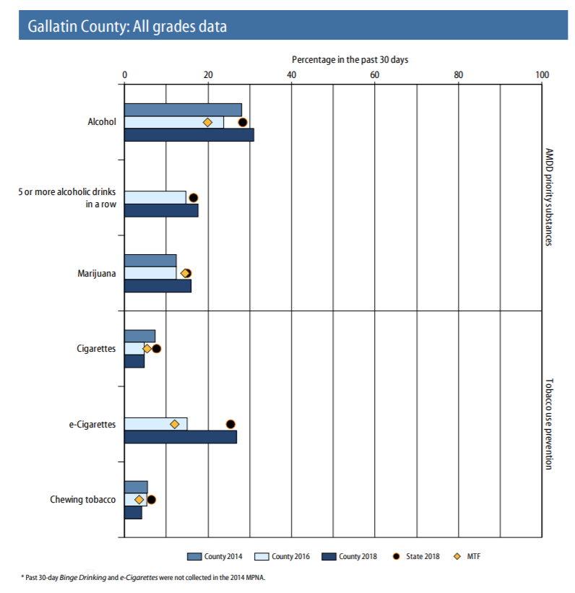

The final high risk factor of “Community Laws and Norms Favorable Toward Drug Use, Firearms, and Violence” is the examination of the high rates of firearm ownership in Gallatin County and in Montana. In Gallatin County, 63% of homes report having a firearm in their home. Additionally, 21% of those report storing their firearms unlocked and loaded. This is especially troubling given 76% of the homes with firearms in them also have children in them. Although Gallatin County does not have high rates of firearm use associated with crime, theft, and violence, suicide rates and injury due to firearms must be considered as an impact to the community. National data suggests that easy access to firearms increases the risk of suicide.

The Communities That Care framework also mentions delinquency and violence as risk factors that contribute towards “Community Laws and Norms Favorable Toward Drug Use, Firearms, and Violence.” Crime rates among youth in Gallatin County have been steadily decreasing since 2014. The top types of crime committed by youth from 2014 to 2019 are crimes against property (includes shoplifting) and status offenses (includes breaking curfew, ungovernable juvenile, and possession of tobacco).

This report would be remiss not to mention suicide rates in Gallatin County and Montana as a whole. Suicide rates can be categorized under violence per the Communities That Care framework. Suicides in youth ages 10-19 is the second leading cause of death nationally. In Gallatin County in the past five years, there were 12 suicides among those under the age of 20. Montana has been in the top five states of suicide for more than 40 years. Suicide is the second leading cause of death among Montanans age 10-44, and firearms are used in over 63% of completed suicides. The problem is even more evident among youth as youth suicide rates in Montana are almost triple the national average.

Other sources of data were consulted as part of this report including unemployment data, Temporary Assistance for Needy Family Enrollment, Supplement Nutrition Assistance Program, and more. These data sources helped provide additional evidence that led the Data Group members to conclusion to focus on “Community Laws and Norms Favorable Toward Drug Use, Firearms, and Violence” as a community level risk factor.

“Research has shown that legal restrictions of alcohol and tobacco use, such as raising the legal drinking age and restricting smoking in public places have been followed by decreases in consumption. Notational surveys of students have shown that shifts in normative attitudes toward drug use have preceded changes in time” (2018 Montana Prevention Needs Assessment Survey, p. 10)

While policies that target any risk or protective factor could potentially be an important resource for students in Gallatin County, focusing prevention planning in high-risk and low-protection areas could be especially beneficial. Similarly, factors with low-risk or high-protection represent strengths that planners can build on. In conjunction with a review of community-specific issues and resources, this information can help direct the efforts of prevention planners.

Risk Factor:
Favorable Attitudes Towards the Problem Behavior

After extensive review of the data, the Data Group selected “Favorable Attitudes Towards the Problem Behavior” as an individual/peer level risk factor because of the high rates of substance use in Gallatin County and favorable individual/peer attitudes towards substance use.

According to the Communities That Care framework, there are a series of measureable outcomes directly linked back to each risk factor. The “Favorable Attitudes Towards the Problem Behavior” is linked to substance use, delinquency, teen pregnancy, school dropout, and violence. Although all contributing risk factors will be examined, the main focus the data group would like to draw attention to is the high rates of substance use, the individual and peer acceptance of substance use, and favorable social norms towards substance use in Gallatin County that impact individual behaviors. Drug use includes the use of alcohol, tobacco, marijuana, and illicit drugs.

The 2017 Youth Behavior Risk Survey examines use of substances among youth and the acceptance of substance use among peers. Reported use of alcohol and vaping substances in the last 30-days is on the rise compared to previous year’s data in Gallatin County. The 2018 Montanan Prevention Needs Assessment reported the 30-day alcohol use for high school students in Gallatin County was reported at 31%. This is higher than the state average for students’ 30-day alcohol usage which was reported at 19.9%. The data also suggests an increase in alcohol use from the 8th grade (15.9%) to the 12th grade (51.8%). Additional data indicates that 17.5% of students in Gallatin County reported binge drinking in the past 30-days².

- Binge drinking is five or more alcoholic drinks in a row.

Figure 3: Gallatin County Reported Intentions To Use from Students – All Grades Data, from the 2018 Montana Prevention Needs Assessment Survey

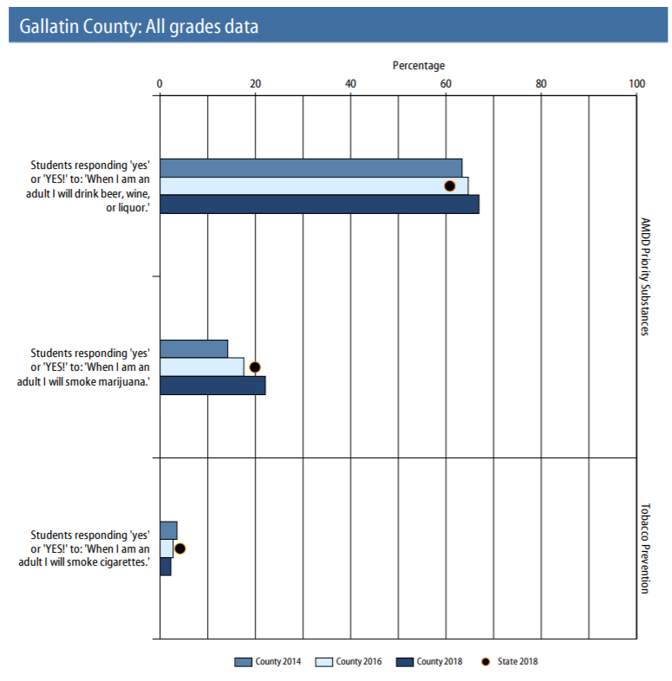

Electronic vaping use in Gallatin County is reported at 37.1% which is 7 points higher than the state average, and an 11 point increase from Gallatin County youth use from 2017. Additionally, frequent use of vapor products has increased from 1.6% in 2017 to 14% in 2018.
When it comes to the use of illicit drugs on school property, measured in the past year, 27% of students report that they were offered, sold, or given an illegal drug. This number is 5 points higher than the state average and an 8 point increase since the last survey. Additionally, when students look towards their future behavior, almost 70% of students report their intent to use alcohol when they are an adult.

Another essential aspect of the data to consider is the perception of youth’s peer’s attitudes towards substance use as this can have a major role on their behavior. Perception of risk ties into favorable peer attitudes. This includes asking students about what risk they perceive with the harm of regular use of alcohol, binge use of alcohol, using marijuana once or twice a week, smoking one or more packs of cigarettes per day, and using smokeless tobacco products. From 2014-2017, most perceptions of risk have remained steady over the years hovering around students thinking that there is “moderate” or “great” risk associated with substance use at 70-80%. However, a large change can be seen in 2017 in the perceived risk of marijuana use. Perceptions of the harm associated with marijuana use have decreased about 15% between 2016 and 2017 according to the latest Montana Prevention Needs Assessment. Although perceptions of risk remain around 70-80%, students still choose to engage in this high risk behavior.

“Young people who associate with peers who engage in alcohol or substance abuse are much more likely to engage in the same behavior. Peer drug use has consistently been found to be among the strongest predictors of substance use among youth. Even when young people… do not experience other risk factors, spending time with friends who use drugs greatly increases the risk of that problem developing” (2018 Montana Prevention Needs Assessment Survey, p. 11)

The older the student is, the more likely a student is susceptible to the perceptions of their peers on their behavior. The greater the peer disapproval, the less likely the student is to use substances. Additionally, student who express personal disapproval toward alcohol or marijuana use by their peers are less likely to use substances. This reflects the changes observed in alcohol use from grades 8 to 12 above.

Finally, the Communities That Care framework also mentions delinquency, teen pregnancy, school dropout, and violence as risk factors that contribute towards “Favorable Attitudes Towards the Problem Behavior.” Fortunately, school dropout rates remain low for Gallatin County and these rates have remained steady from 2014 to 2019 at around 3.1%. This is lower than the state average of 3.6%.

Teen pregnancy also appears not to be a substantial risk factor. In Gallatin County, the average teen pregnancy rate among women ages 15-19 is 15.3 per 100,000. This teen pregnancy rate is lower than Montana and national averages and has continued in a steady decline since 2002.

In terms of interpersonal and peer violence, again suicide must be mentioned. Students who report having seriously considered suicide in the past year was reported at 24.5% for Gallatin County, and increase of 6.7 points since the 2015 survey. Attempted suicide for youth in Gallatin County was 14.1%, an increase of 4.4 points since 2015.

Other sources of data were consulted as part of this report including unemployment data, Temporary Assistance for Needy Family Enrollment, Supplement Nutrition Assistance Program, and more. These data sources helped provide additional evidence that led the Data Group members to conclusion to focus on “Favorable Attitudes Towards the Problem Behavior” as an individual/peer level risk factor.

Conclusion and Recommendations

Gallatin County’s Strengths
The data indicated that young people in Gallatin County may be motivated by opportunities for prosocial involvement. The 2018 Montana Prevention Needs Assessment Survey indicates that if community opportunities are offered for prosocial involvement, 78.7% of Montana students will be provided with some protection against risk factors. Additionally, about 55% of Gallatin County high school students report not having a drink of alcohol in the past year. Gallatin County should focus on this strength while enhancing other protective factors in its prevention efforts.

Community Priorities
Based on the analysis of the data and input from community partners, the following priority risk factors were identified for the community to focus on over the next several years:

- Community laws and norms favorable towards drug use, firearms, and crime (Community Domain)
- Favorable attitudes toward the high risk behavior (Peer and Individual Domain)

These risk factors were selected as priorities because the data indicated that they are among the most elevated throughout Gallatin County. We recommend that Gallatin County give particular attention to implementing strategies or programs to address these two risk factors when developing a prevention plan. While policies that target any risk or protective factor could potentially be an important resource for students in this county, focusing prevention planning in high risk and low protection areas could be especially beneficial.

Next Steps
The next step in the Communities That Care process is to find out what resources are already in place in Gallatin County that address the priorities outlined above. The Resources Assessment and Evaluation work group will attend the Assessing Community Resources Workshop in June. Their assessment combined with this report, will make a complete profile of Gallatin County that will be used to identify programs and strategies to promote child and youth well-being and prevent high risk behavior and poor health outcomes in Gallatin County.

Acknowledgements

This report was made possible because of support from the following Gallatin County, MT Communities That Care supporting organizations.

Alcohol and Drug Services of Gallatin County

Belgrade Community Library

Belgrade Police Department

Belgrade School District 44

Big Sky Youth Empowerment

Bozeman Health

Bozeman Police Department

Bozeman Public Library

Bozeman School District 7

City of Bozeman

Cherry Blossom

Civic Consulting

Community Health Partners

Cook Real Estate

Elks Drug Awareness Program

Gallatin City-County Health Department

Gallatin County

Gallatin County Attorney’s Office

Gallatin County Commission

Gallatin County Schools

Gallatin County Sheriff Department

The Gallatin Valley YMCA

Greater Gallatin United Way

Help Center, 211

Human Resource Development Council

MSU Extension Service

MSU University Health Partners

Montana Department of Public Health and Human Development, AMDD

Mustang Worthy, LLC

St. Catherine Health

The Rock Youth Center

The Town of West Yellowstone

Western Montana Mental Health Center

Young Life

Youth Dynamics, Inc.

References

2018-2019 Annual Report: Office of the Dean of Students, Montana State University. Published Spring 2019.

Bozeman Health, Community Health Partners, and Gallatin City-County Health Department. (2017, October). 2017 Community Health Needs Assessment Report: Gallatin, Madison, and Park Counties, Montana.

Communities That Care (2020). University of Washington, Center for Communities That Care.
www.communitiesthatcare.net

Department of Public Health and Human Services, Montana. (2018). 2018 Montana Prevention Needs Assessment Survey.

Department of Public Health and Human Services, Montana. (2019). Tobacco Retailer Data by County, provided by private source.

Department of Public Health and Human Services, Montana. (2019). Unemployment Data by County.

Montana 2016 Suicide Mortality Review Team Report. (2016). Montana Department of Public Health and Human Services. Retrieved October 22, 2019, from https://www.sprc.org/sites/default/files/resource-program/2016 Montana Suicide Mortality Review Report.pdf.

Montana Board of Crime Control. (2019). Youth Crime Data by County, provided by private source.

Montana Office of Public Instruction. (2019). 2019 Montana Youth Risk Behavior Survey High School Results.

Rosston, K. (2018, August). Suicide in Montana: Facts, Figures, and Formulas for Prevention. Retrieved October 22, 2019, from https://dphhs.mt.gov/Portals/85/suicideprevention/SuicideinMontana.pdf

Temporary Assistance for Needy Families (TANF) Enrollment, Montana. (2019). Enrollment Data by County.

Supplement Nutrition Assistance Program (SNAP) Participant Data, Montana. (2019). Supplement Nutrition Assistance Program (SNAP) Participant Data by County.

